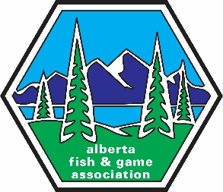
2022 REMITTANCE FORM

The Alberta Fish and Game Association
13045 156 Street NW, Edmonton, AB T5V 0A2
Phone: 780-437-2342
Email: membership@afga.org

Submitted Roster Name: (e.g. January 2022)

Club Name:

Membership Contact:
(Any changes to membership chair please contact head office immediately)

Daytime Phone Number:

Email Address:

(R) REGULAR Memberships @ $45.00 =

(F) FAMILY Memberships @ $60.00 =

(D) DEPENDANTS (applies to Family memberships only) are
considered to be the partner/spouse and any children under 18 at time of
registration, residing in the same household

(Y) YOUTH Memberships
(Individual members under the age of 18 at time of registration)
@ $20.00 =
TOTAL OF ALL MEMBERS on this roster
(This number must include Dependants)

TOTAL AMOUNT = $
Club affiliation is available to any group of 20 or more individuals that subscribes to the objects of the AFGA and whose expressed aims are the renewal of our fish, wildlife, and natural resources and their conservation and management for the future.

Additional Information/Comments:

